|  |  |
| --- | --- |
| Name | Rihan Riyaj Chougule |
| PRN | 245100105 |
| Batch | S4 |
| Branch | CSE(Aided) |
| Subject | Object Oriented Programming – Assignment -1 |

**Assignment No 4**

* Write a Menu Driven program to perform following operations on Doubly linked list.
  + Insert new element at Beginning, End and middle position.
  + Delete element from Beginning, End and middle position.
  + Display Linked List.

Answer Code- 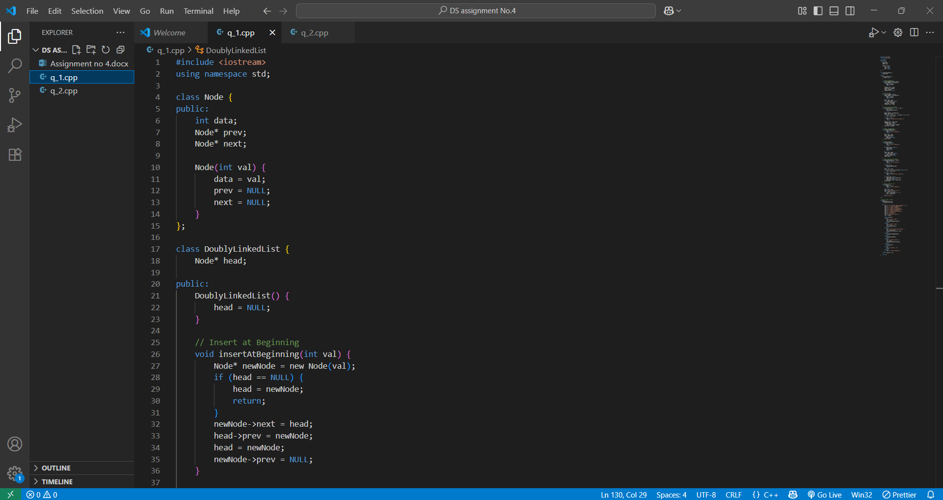

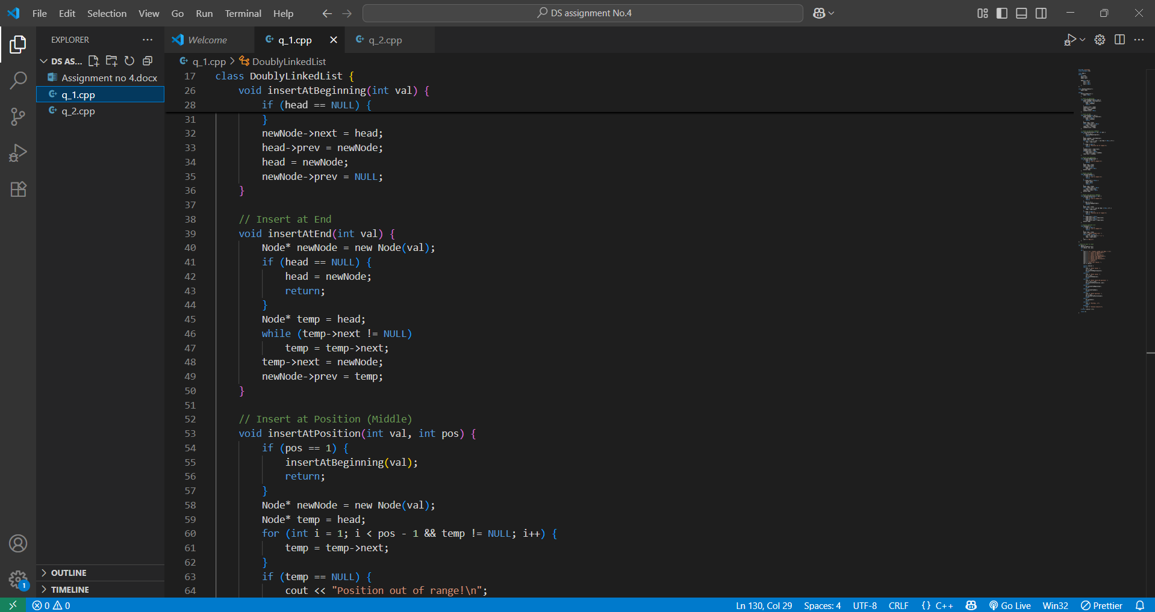

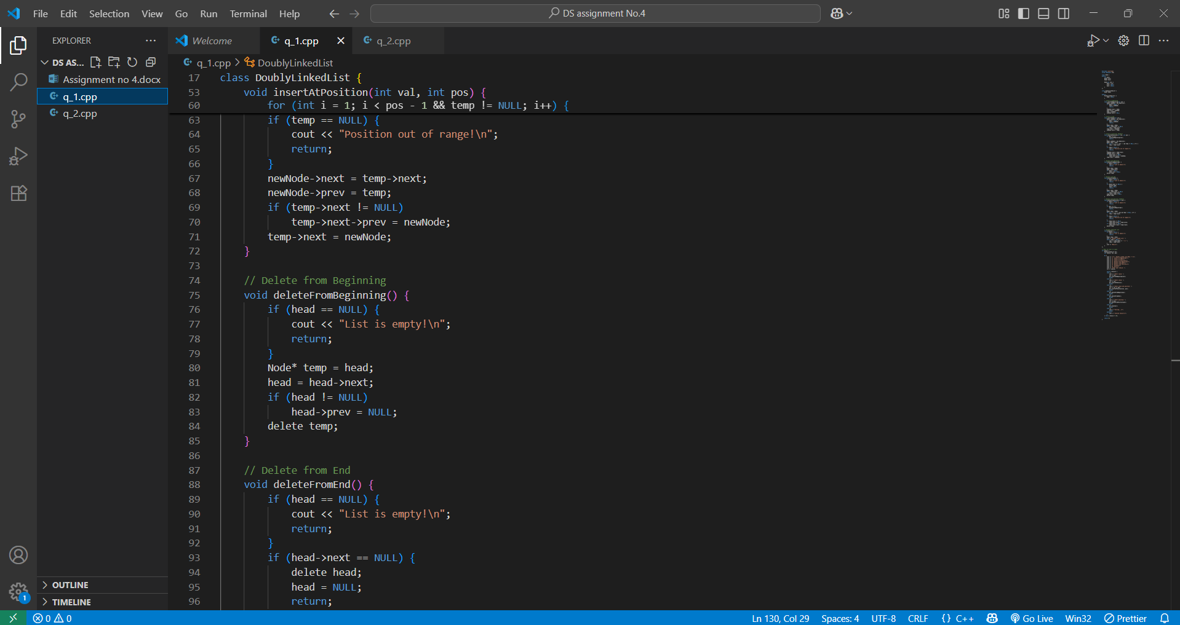

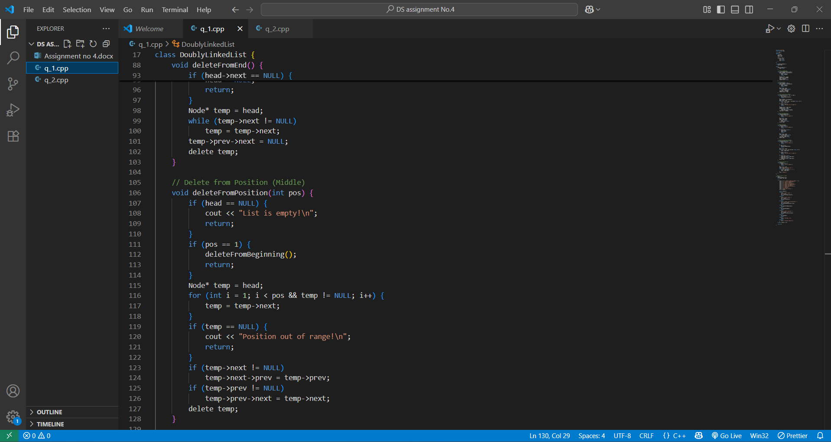

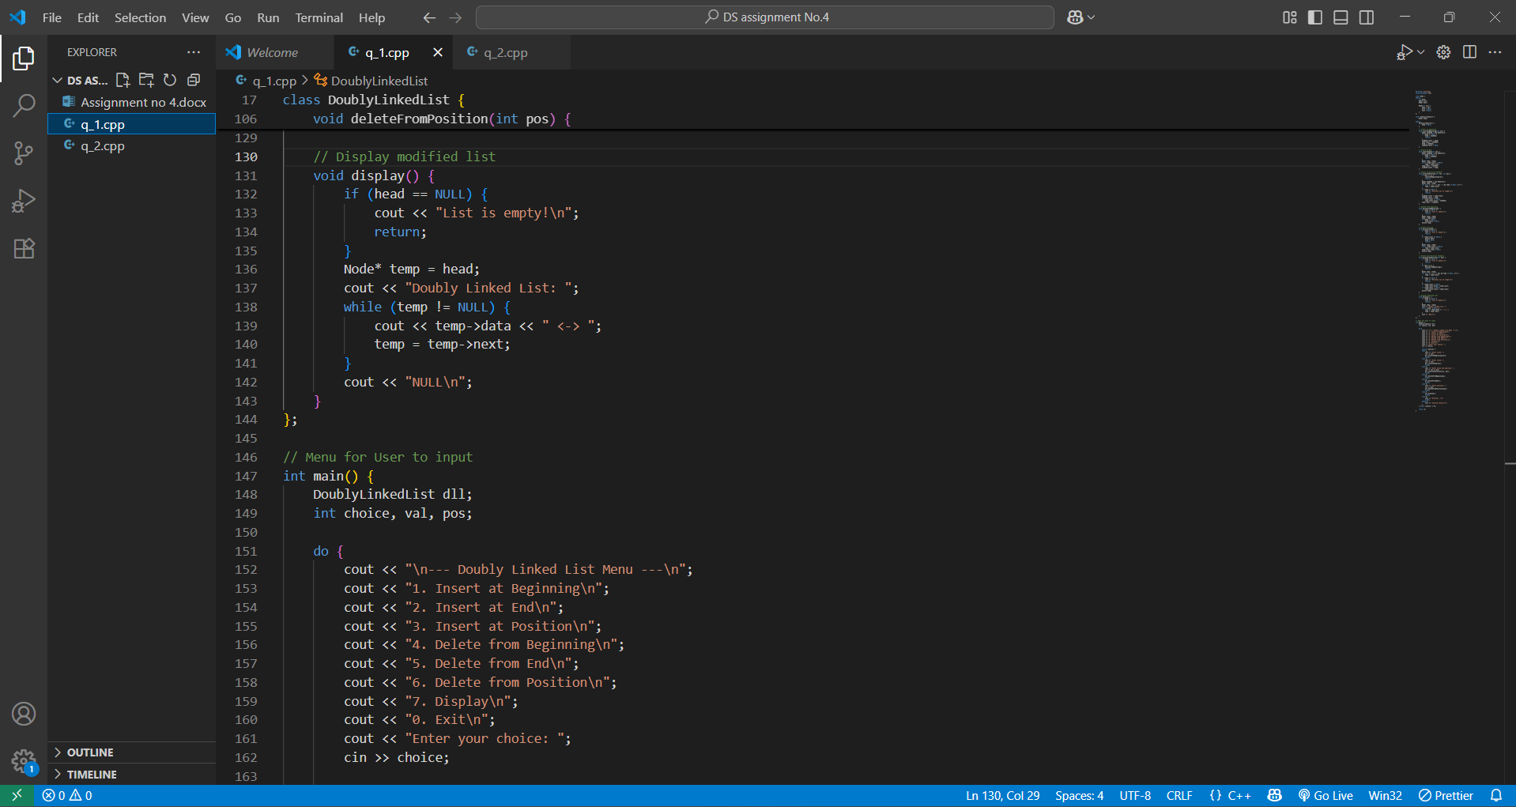

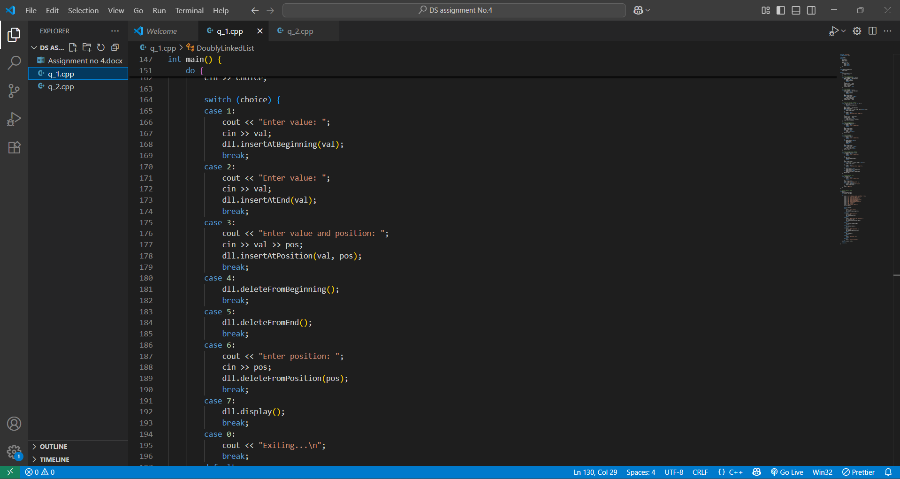

Output-

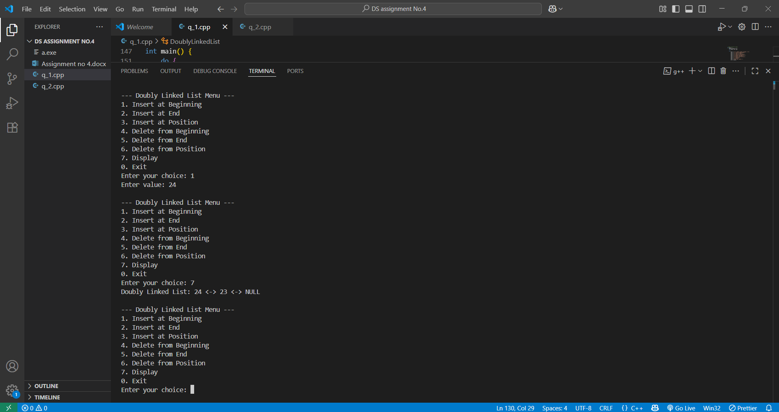

* Write a program to Reverse Doubly Linked List.

Answer Code- 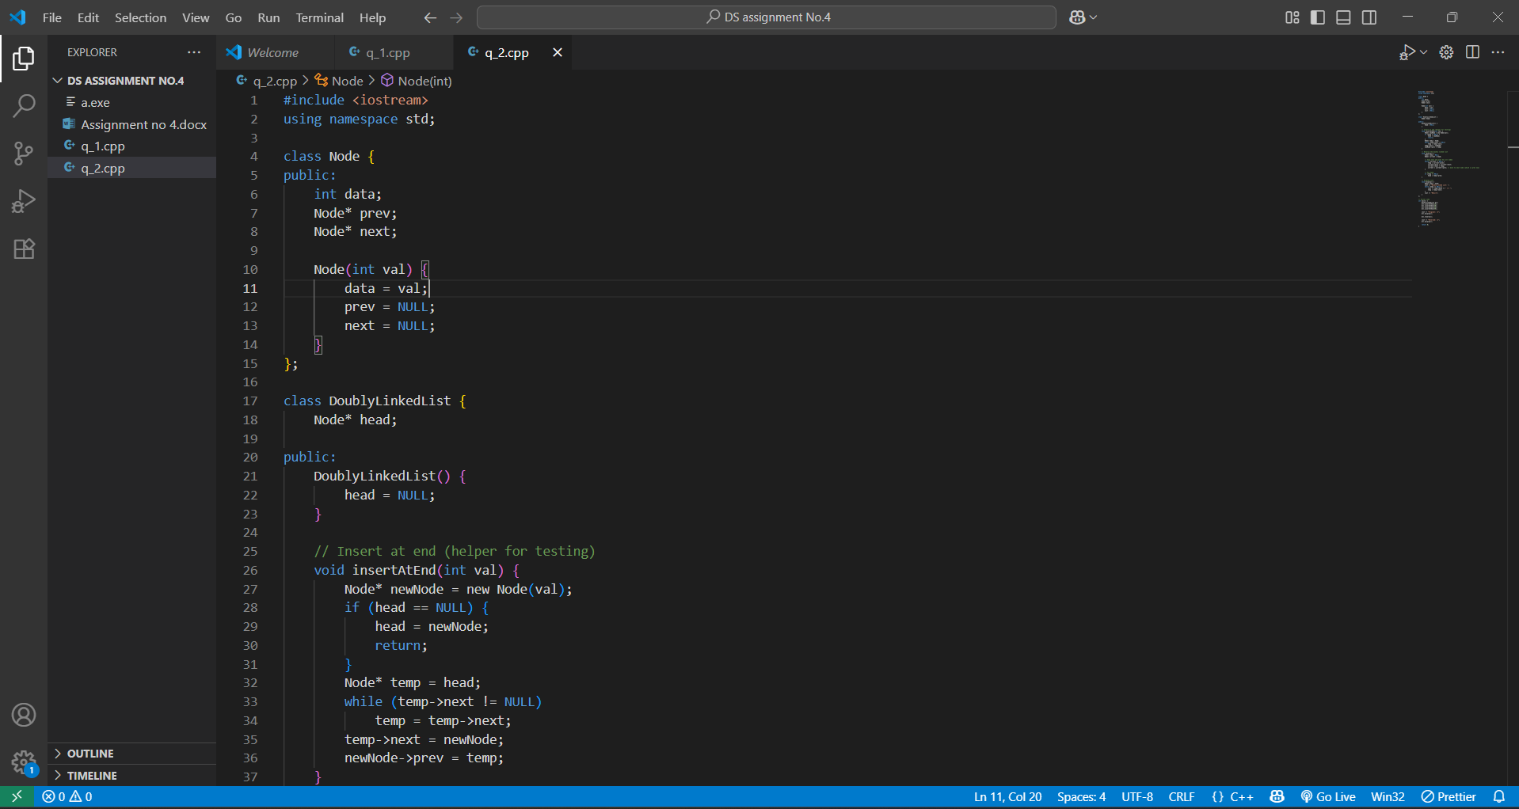

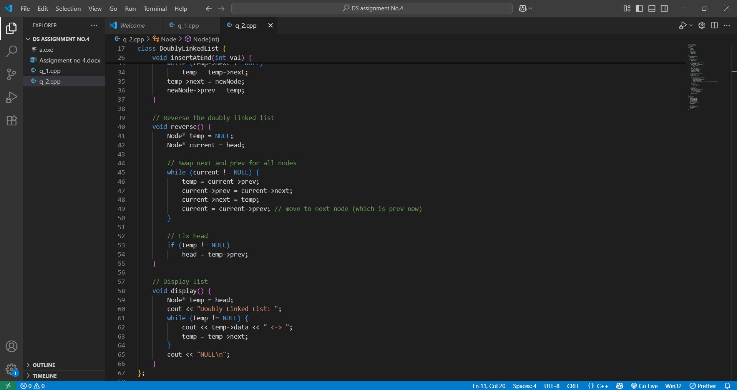

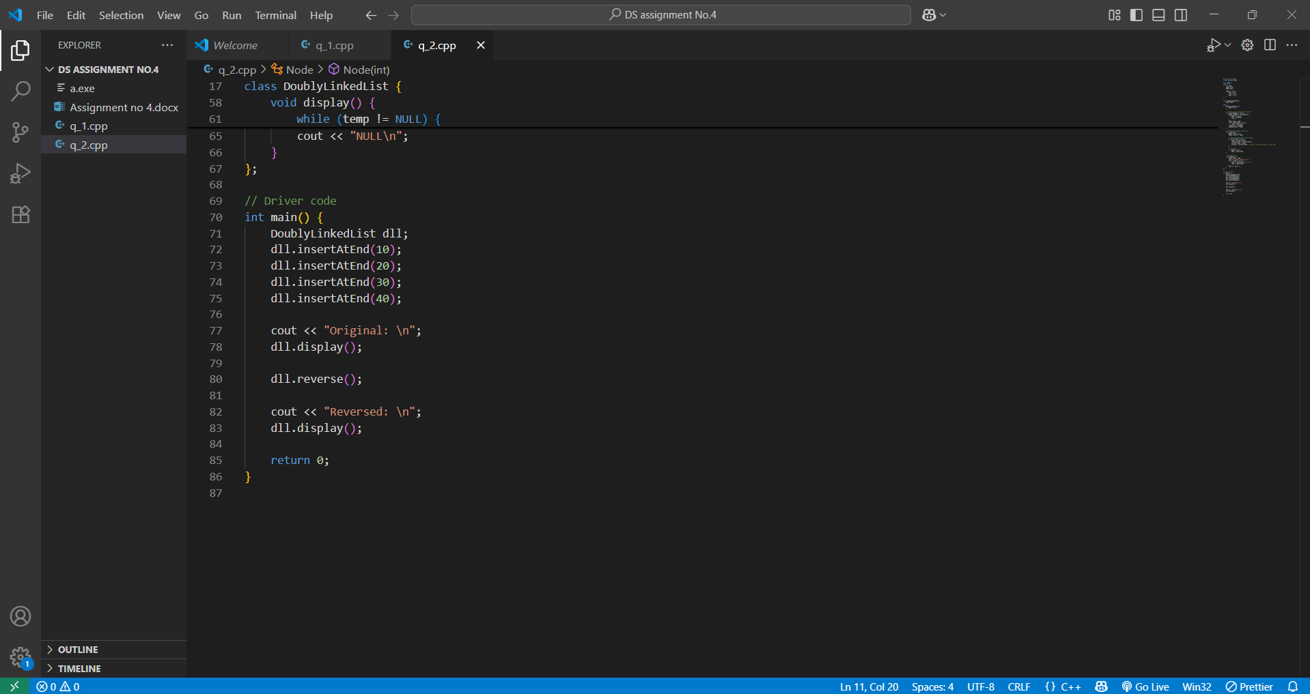

Output-

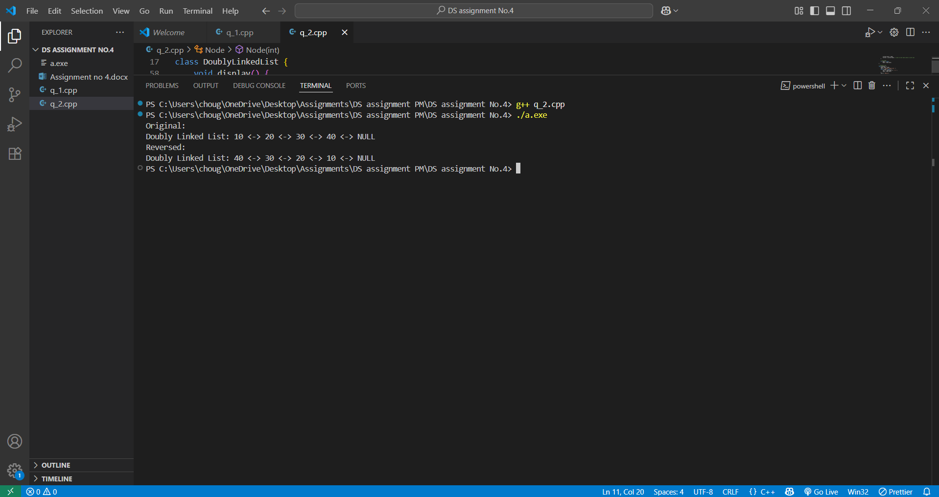

* Write a program to Sort given Doubly Linked List.

Answer Code-

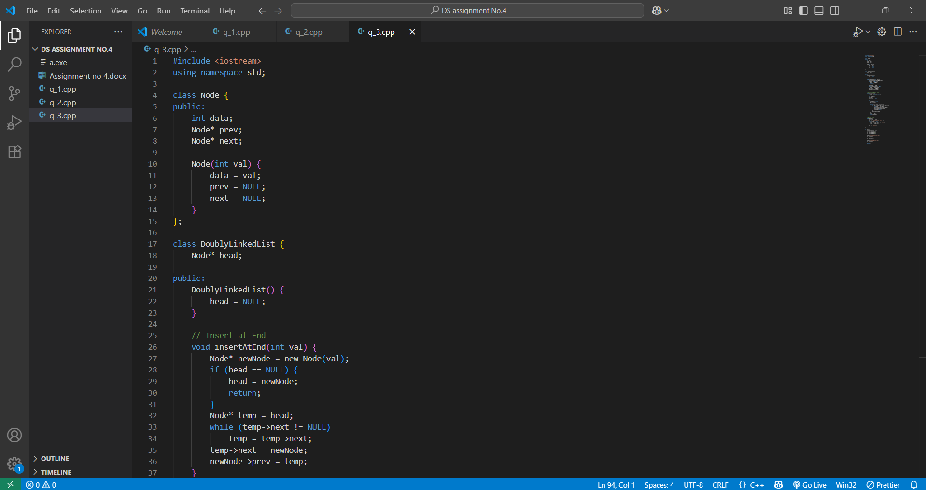

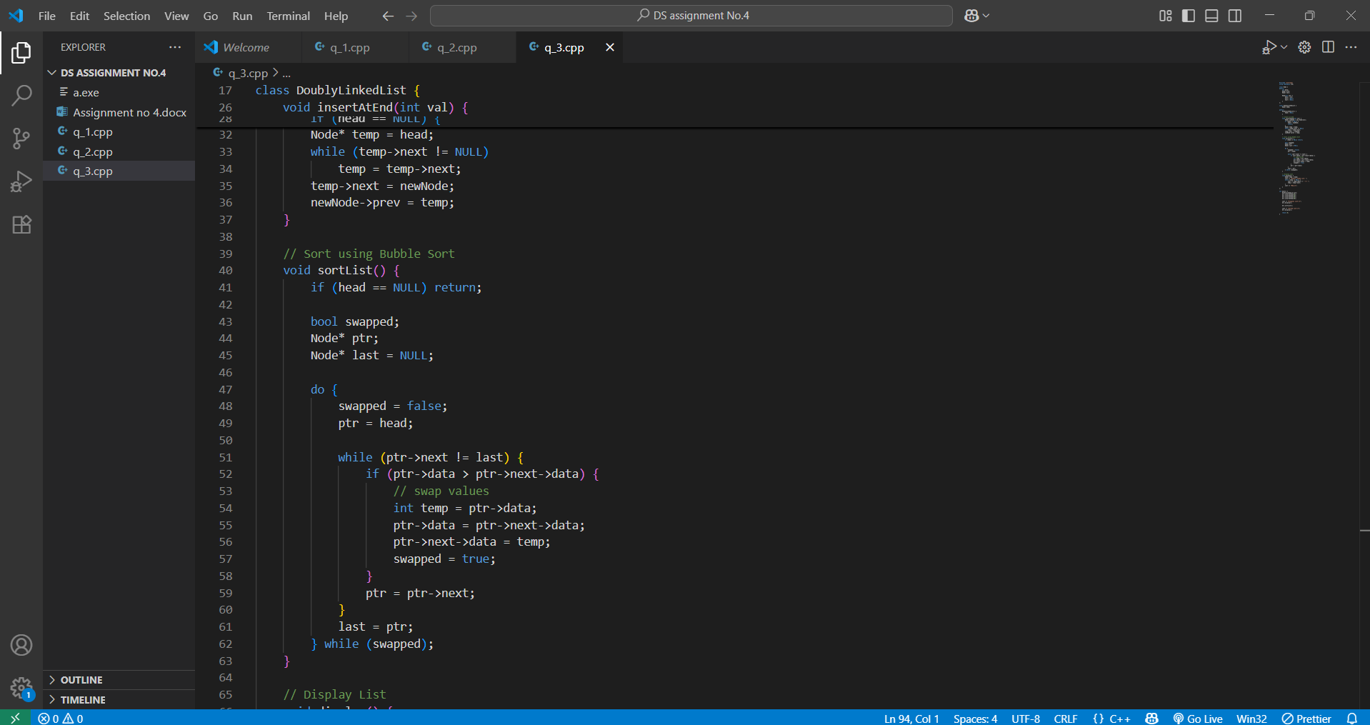

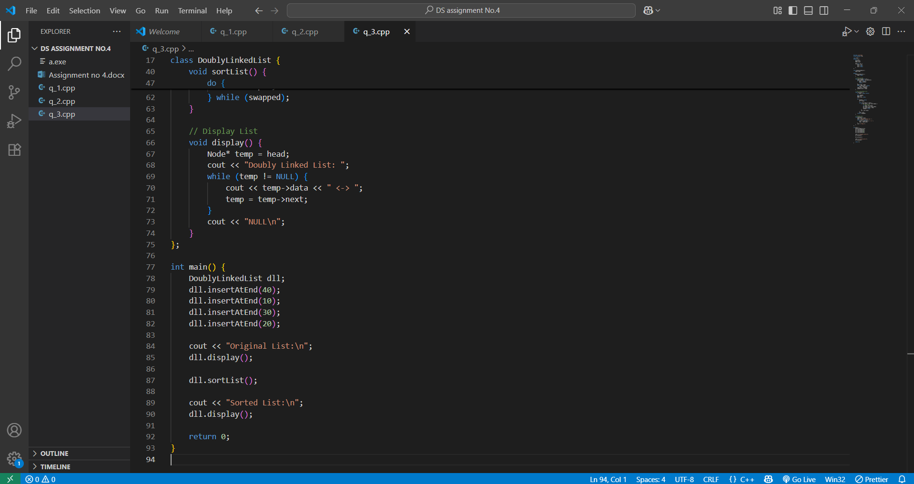

Output-

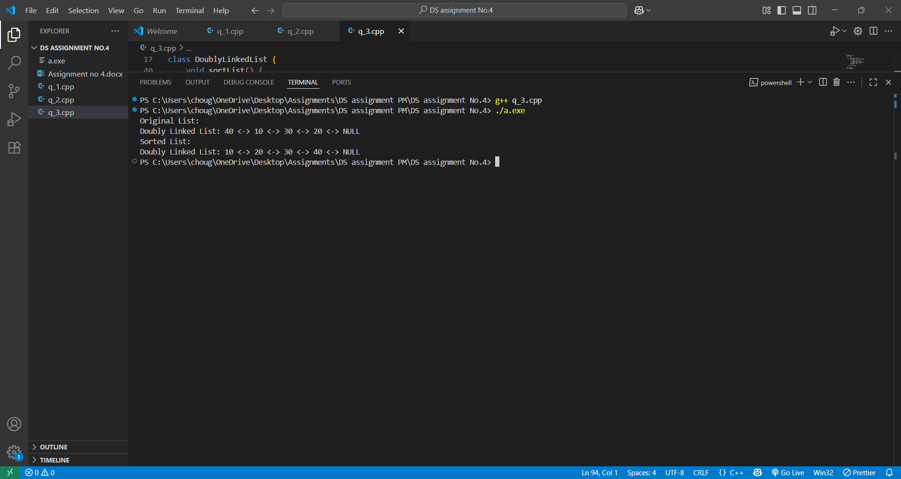

* Write a program to concatenate two Doubly Linked Lists.

Answer Code- 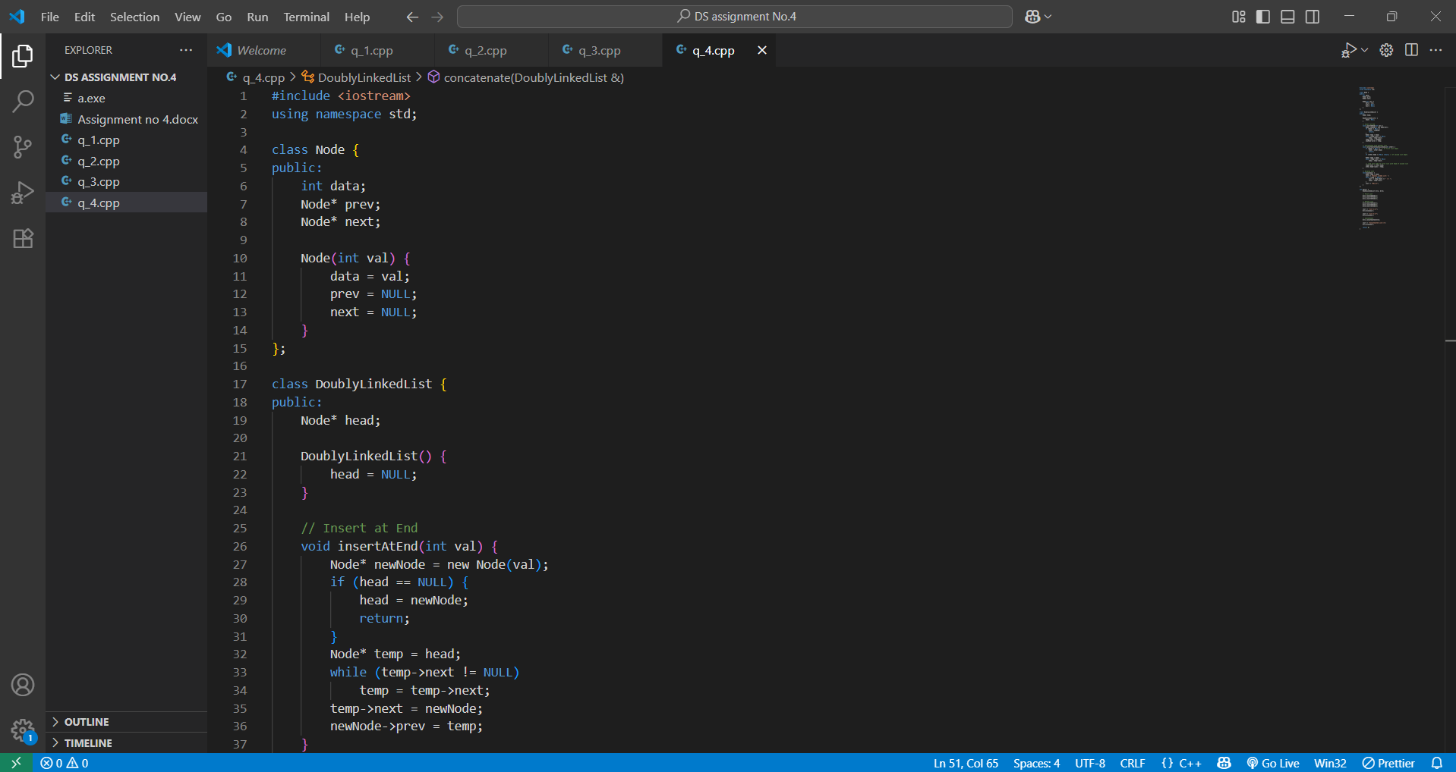

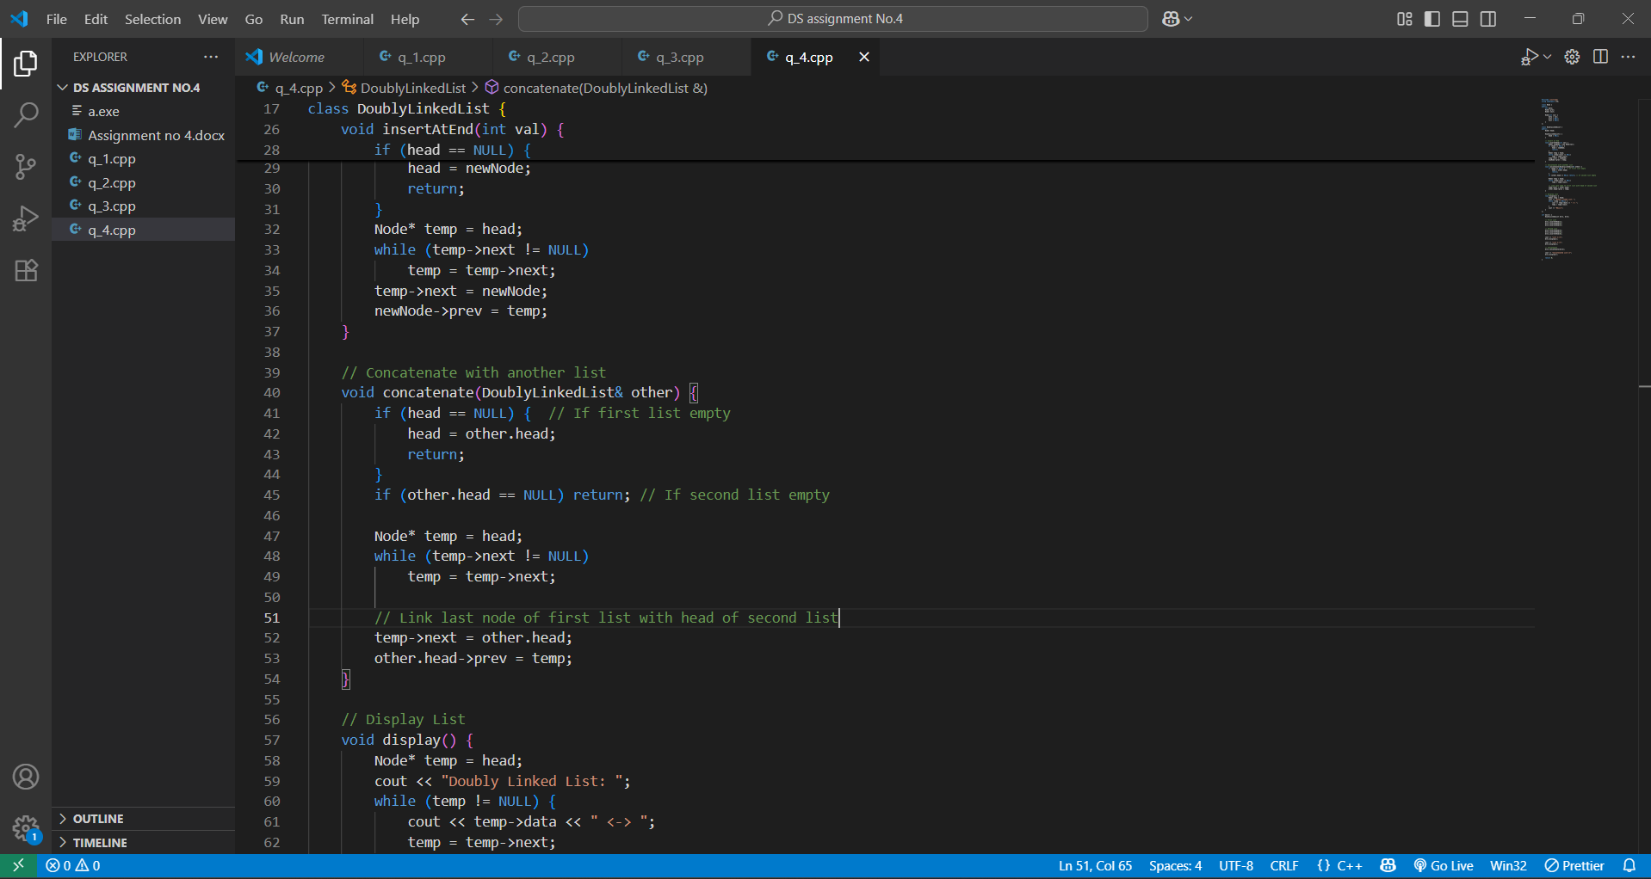

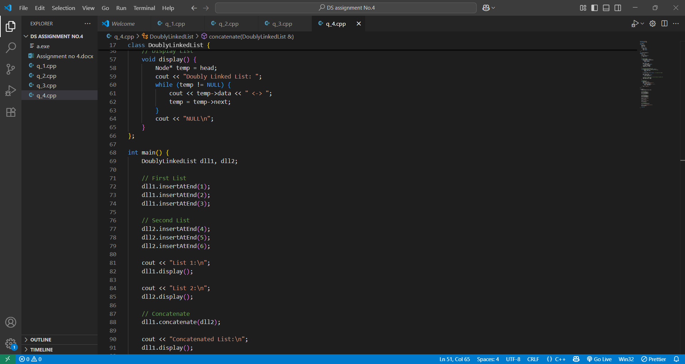

OutPut-

